|  |
| --- |
| ***Immaculate Conception Parish***  P O BOX 600 Tumut  Catholic Community  Collection amounts for January 2016 ~PARISH NEWS~  ~ PARISH NEWS ~  **~ GOSPEL REFLECTION ~** |

Today is Social Justice Sunday in Australian Catholic Communities. In the choice of title for their Social Justice Statement, the bishops remind us that Australia aspires to be “a place of welcome and inclusion”. The cover image of a veiled woman holding her child evokes the plight of displaced women and children in so many parts of our world. It evokes the desperation of women and children in detention on Nauru who now face the prospect of being sent for medical treatment to Port Morseby in Papua New Guinea, a country whose resources are already stretched to the limit. We need to learn again what it means to be a good neighbour in our region and in our world. This document deserves our attention for many reasons, but particularly for the sake of the children who seek our protection. *An excerpt by Sr. Veronica Lawson*

***PLENARY COUNCIL PRAYER***

Come, Holy Spirit of Pentecost. Come, Holy Spirit of the great South Land. O God, bless and unite all your people in Australia and guide us on the pilgrim way of the Plenary Council. Give us the grace to see your face in one another and to recognise Jesus, our companion on the road. Give us the courage to tell our stories and to speak boldly of your truth. Give us ears to listen humbly to each other and a discerning heart to hear what you are saying. Lead your Church into a hope-filled future, that we may live the joy of the Gospel. Through Jesus Christ our Lord, bread for the journey from age to age. Amen. Our Lady Help of Christians, pray for us. Saint Mary MacKillop, pray for us.

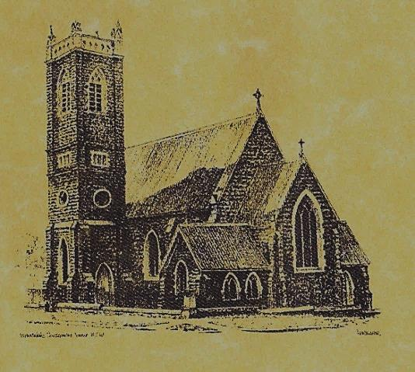

**‘CLERGY’**

**Fr. George Ogah (Administrator) Fr. Namora Anderson (Assisting Priest)**

**‘PARISH SECRETARY’**

**Anna Quinn**

**Phone: 02 69474599**

**Fax: 02 69474602**

Email: tumut@cg.org.au

Web: www.cg.org.au/tumut

Office hours: Wednesday & Friday 9am -12noon

-------------------------------------------------------- **‘WEEKEND MASS TIMES’**

**Saturday Vigil: 6pm**

**Sunday: 10am Talbingo 8am**

**‘THIS WEEKS MASS TIMES’**

**Tuesday: 6pm in Chapel**

**Wednesday: 10am**

**Thursday & Friday: 8am in Chapel**

**Saturday: 9am**

**‘ROSARY’ Saturday: 8.45am**

**Exposition 8.30am (1st Sat of month)**

**‘RECONCILIATION’**

**Saturday at 5.15pm**

**‘LITURGY MEETING’**

**Tuesday: 2.00pm in Chapel**

**‘PRAYER GROUP’**

**(Rosary & Divine Mercy)**

**Wednesday: 2.00pm in Chapel**

**‘CONTACTS’**

**Care Group: Anne Huebner 69473406**

***Gospel Acclamation***

**Alleluia, alleluia! Your word, O Lord, is truth: make us holy in the truth. Alleluia!**

***Responsorial Psalm***

**The precepts of the Lord give joy to the heart.**

***Entrance Antiphon***

**All that you have done to us, O Lord, you have done with true judgement, for we have sinned against you and not obeyed your commandments. But give glory to your name and deal with us according to the bounty of your mercy.**

**26th Sunday in Ordinary Time Year B**

**September 30th 2018**

***Gospel Acclamation***

**-----------------------------------**

Alleluia, alleluia! Tomorrow the wickedness of the earth will be destroyed; the Saviour of the world will be our king. Alleluia!

|  |  |  |  |
| --- | --- | --- | --- |
| T THIS WEEK Saturday & Sunday 29th & 30th September | | | |
| Ministry | Saturday Vigil 6pm | Sunday 10am | |
| Acolyte | Trish Matthews | Mark Hogan | |
| Reader | Dobbie Family | Sue Bulger | |
| Commentator | Dobbie Family | John Power | |
| Children’s Liturgy | ---------- | ------------ | |
| Musicians | Patricia & Monica | Patricia & Monica | |
| Altar Servers | Abby Crampton & Olivia Dean | Gabbi & Maggi Dalisay | |
| Church Care  ________________________  LINEN Jo Little | Group 3: Yvonne, Lee, Mary, Colleen & Kath | | |
| NEXT WEEK Saturday & Sunday 6th & 7th October | | | |
| Ministry | Vigil 6pm | | 10am |
| Acolyte | Tony Butler | | Anne Huebner |
| Reader | Anita Mason | | Howard Young |
| Commentator | Claire Cole | | Mary Kelly |
| Children’s Liturgy | ---------- | | ---------- |
| Musicians | Patricia & Monica | | Anna Quinn |
| Altar Servers | Jessica & Emily Kelly | | Xavier Henderson & Riley Hotham |
| Church Care | ---------------------------------------- | | |

Feast Day**Wishing all ouFEASTS DAYS**

R O S T E R S

**Feast Days 1st Oct: Saint Therese of the Child Jesus 2nd Oct: The Holy Guardian Angels 4th Oct: Saint Francis of Assisi**

**What we are doing to the forests of the world is but a mirror reflection of what we are doing to ourselves and to one another. *Mahatma Gandhi 1869-1948***

**~PARISH NEWS~**

**THANK YOU** Fr. Michael for your service to our parish during the month of September, it has been a pleasure to have you in our lovely town, we wish you well and God bless you. **WELCOME BACK** Fr. George who will return from his leave next week. **SATURDAY MORNING MASS** will resume next Saturday. Talbingo Mass will also resume after the winter break.  **MARION PROCESSION AND YOUTH PILGRIMAGE 2018** will be held on Sunday 14th October at St. Clement’s Retreat Galong, with the procession to the grotto starting at 2pm. See flyer on notice board for more information. **PLENARY COUNCIL 2020**: **“Listen to what the Spirit is saying”** Please return your questionair this weekend to the box in the Church foyer. If you have not completed one, there are spares on the table at the back of the church. Thank you for your efforts. **SPECIAL THANKS** this weekend to our Church Care ladies **~Yvonne Lee Mary Colleen & Kath~**

**We pray for those who have gone before us marked with the sign of faith:**

**MASS HAS BEEN REQUESTED FOR:**

Natalie Baker, Col Baker, Eric Harris, Andrew Sturt, Fr. Peter Quirk, Sr. Dorothy Bray RSM, Jim Lynch, Paul Kelly, Chris Ballard, Van de Brug families, Breward families, Frank, Eileen & Marie Malone, Louis Shallow, John Callister, Maude Kelly, Leo Aarts, Maria Tran, Mick Bristow, Maureen Court, Andrew Sturt., Brian Rosetta, Hassel & Joy McGrath, Noel Cook, Rudi & Filomena Comai, Gus & Kath Clout, Ab & Mildred Shanahan, Ina Clout, Pat Malone, Joan Malone, Frank Delany, Ken & Brian Gee, Max Butler, Imelda, Bede & Francis McInerney, John Hourigan, Russell & Peter Ritchie, Peter Bush, Alan Guthrie, Jim McInerney, Kath Stuckey, Iris Stuckey, Minnie Murphy, Alfred & Bridget Claffey, John Marzol, Sean Gordon, Maureen Ashleigh, Tom Sturt, Edward Mary & Clem Malone, Pat Malone, Reg & Mary Madigan, Matt Downing, Wilkinson & Downing families, Frank Stanfield, James Kelly, Tom & Dorothy French.



[](http://www.google.com.au/url?sa=i&source=imgres&cd=&cad=rja&uact=8&ved=0CAkQjRwwAGoVChMI7K2CkrGjxwIV5SWmCh0TNwb2&url=http://www.can.org.au/News/216/Big_thanks_to_ChillOut.aspx&ei=XybLVayCBuXLmAWT7piwDw&psig=AFQjCNFa5XonRxBDPuH7vZduLQA2OEEhbQ&ust=1439463391209159)