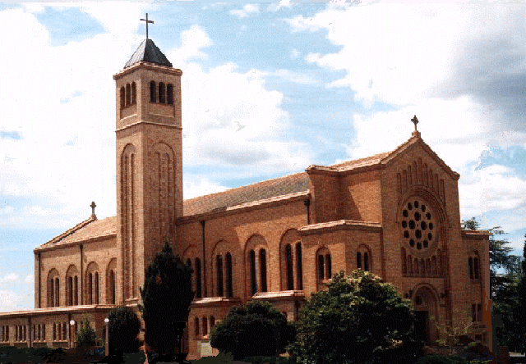 St Christopher’s Cathedral

Cnr. Canberra Avenue and Furneaux Street, FORREST ACT 2603

Parish Office: Ground Floor, 55 Franklin Street, FORREST ACT 2603

Tel: +61 (02) 6239 9846, Email: cathedral@cg.org.au

[www.cg.org.au/cathedral](http://www.cg.org.au/cathedral)

10 January 2020

Dear Parents/Guardians,

**ST. CHRISTOPHER’S CATHEDRAL PARISH**

**FIRST RECONCILIATION PROGRAMME, 2020**

I write this letter to invite you to attend the **Parent Evening** in **St Peter Chanel’s Parish Room, Weston Street, Yarralumla**, on **Monday, 15 June 2020** at **6.00-7.30pm.**

Some years ago you presented your child for Baptism and made a commitment to accept the responsibility of raising your child in the practice of the faith. First Reconciliation is the next major step in your child’s journey of faith.

Within our Parish the children are prepared for this Sacrament within a Parish School/Parish School of Religion Programme. As with the previous Sacraments your child has celebrated, the programme allows you, their parents/guardians, to accompany your child on their journey of faith. It is also an opportunity for you to re-examine or renew your own faith commitment.

At our meeting on Monday 15 June, all aspects of the Reconciliation Programme will be outlined by our Parish Sacramental Team (see below for full list of dates and times for the Reconciliation Programme). Please note that Classes #2-4 involve a half-hour Family Group Activity from 7pm-7.30pm, which parents are asked to attend. More information will be provided at the Information Evening/Class #1 on Monday night.

The **Sacrament of First Reconciliation** will take place in St. Peter Chanel’s Church, Yarralumla on **Wednesday, 29 July 2020 at 6pm**.

Please find attached a Sacramental Program Enrolment Form. This form needs to be returned to Michelle O’Connor, Cathedral Parish Secretary, with a copy of your child’s Baptismal Certificate, by Wednesday 10 June.

For further information, or if you cannot be present on 15 June, please contact the Parish Office on 6239 9846 or email cathedral@cg.org.au.

I look forward to meeting you on 15 June 2020.

Yours sincerely in Christ,

**Fr Trenton van Reesch**

**Cathedral Administrator**

|  |  |  |  |
| --- | --- | --- | --- |
| **Date** | **Time** | **Event** | **Location** |
| Mon 17 June 2019 | 6-7.30pm | Information evening and Class #1 | St Peter Chanel’s Parish Room, Yarralumla |
| Mon 24 June 2019 | 6-7.30pm | Class #2 and Family Group Activity | St Peter Chanel’s Parish Room, Yarralumla |
| Mon 1 July 2019 | 6-7.30pm | Class #3 and Family Group Activity | St Peter Chanel’s Parish Room, Yarralumla |
| School holidays |  |  |  |
| Mon 22 July 2019 | 6-7.30pm | Class #4 and Family Group Activity | St Peter Chanel’s Parish Room, Yarralumla |
| Mon 29 July 2019 | 6-7.30pm | Class #5 and Family Group Activity | St Peter Chanel’s Parish Room, Yarralumla |
|  |
|  |
| Mon 5 Aug 2019 | 6-7.30pm | First Reconciliation | St Peter Chanel’s Church |