Divine Will Retreat 2019
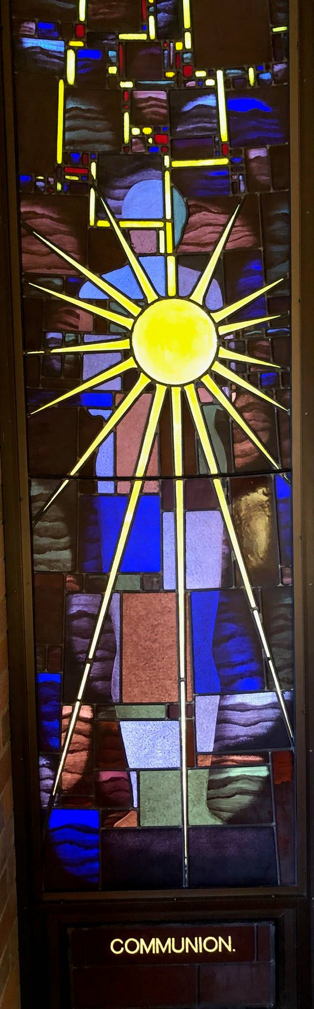
Galong by Fr Emil Milat
Archdiocese Canberra and Goulburn, Aust
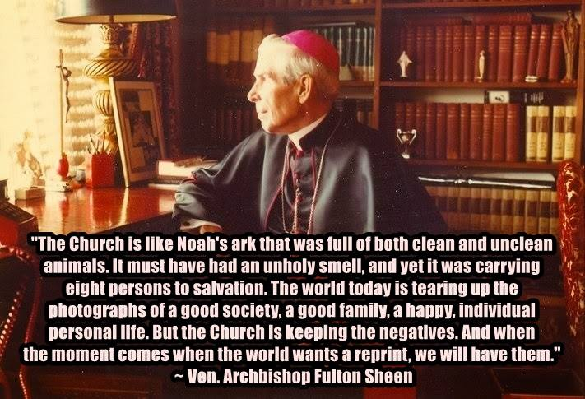
Colossians 1:9-11

Through perfect wisdom and spiritual understanding, may you reach the fullest knowledge of God’s will. So you will be able to lead the kind of life which the Lord expects of you, a life acceptable to him in all its aspects; showing the results in all the good actions you do and increasing your knowledge of God. You will have in you the strength, based on his own glorious power, never to give in, but to bear anything joyfully.

James 4:5 New International Version (NIV)
Or do you think Scripture says without reason that he jealously longs for the spirit he has caused to dwell in us?

Blessed Virgin Mary in the Kingdom of the Divine Will
Now, my child, place your hand upon your heart, and tell your Mama: do you feel your nature changed into virtue? Or, do you feel the thorns of impatience, the noxious herbs of agitations, the bad humors of affections which are not holy? Listen – let your Mama do it; place your will into my hands, determined in not wanting it anymore, and I will make you be possessed by the Divine Will, which will banish everything from you; and what you have not done in many years, you will do in one day, which will be the beginning of true life, of happiness, and of true sanctity.

One of the striking things about the Divine Will, is the claim by Jesus in the writings is that it will be the third renewal by showing what Jesus’ divinity did in his humanity ( Vol 12. 29/1/1919). Jesus in fact says that the sign of a new era being close is the expectation of it (Vol 15. 14/7/23). With this audience I am safe saying that this is close, with knowledge of the Marian apparitions from Fatima to Medugorje (currently official pilgrimages now allowed by the Pope).
With the writings of the saints until this point we get the knowledge of how to reach the highest of union with God. Indeed each has a particular path up this mountain from Franciscan poverty, Jesuit mediation to charitable works orders. These great saints when they reach that point seem to die or fade away in their writings. Like St Thomas Aquinas who said (upon the revelation of God at the end of his life) that all he wrote to date was grass and he did not write any more. Our own Mary Mackillop towards the end of her life said that she no longer desired to pray for anything eg. growth of her order only know that his will be done (letter to mons Kirby – Office of Readings for her feast day).
But Luisa and the Book of Heaven actually begins at this point. Jesus uses the analogy that if you have silver ore no matter how much you refine it you will not get gold, you need gold ore for this. Jesus is opening these doors to Divine Will (Vol 16. 5/8/23). And these writings are ore of the highest possible spiritual kind. By reading them you yourself are refined to such a degree that the Divine Life of God grows in you. But surprisingly in a way that you can live on earth. In fact Jesus says that all of heaven is looking at you, we are the centre of the drama because those in heaven have a completed level of Divine participation but earth is the only place where God’s glory can be increased, so to speak, for all regions (heaven, earth and purgatory) because God’s glory is not yet reigning here in his Divinity fully glorified by His creations (see Vol 33 24/9/ 1934).
The essential ingredient in this refiner’s fire of the Divine Will is abandonment (Vol. 16. 10/2/24). This is not just a physical poverty or even obedience of acceptance of another’s will (even the circumstances that life demands) but deep psychological surrender (Vol. 17. 18/9/24)- to be disposed to the greatest of sacrifices.
We can see why it is in this time that the Divine Will has been given by Jesus. With the modern technology from contraception, to internet and affluence in general; never before have human beings been given potential to fulfilling of the “desires of the flesh” 1 Jn 2:16-17. Even more with globalisation combining with the huge fall in practise of religion (let alone Sunday Mass Catholic faith practise) all the elements are present for people to feel the intellectual and emotional ease to forget God. Given we are such a social being it is the greatest of sacrifices (source of dependence in God) to be open and read about mystical theology at this level. (Vol 12. 8/2/20 the world wants to cast Jesus away but he is creating his third Fiat). The Vatican Council II set the church on this course to “conquer” the modern world though prayer rather than an Old Testament avoidance approach. We need Divine Will life in our veins to do this.
Yet there are many good and disinterested souls who long for God, and these revelations can be heard emerging from other spiritual voices in the Christian World (eg. Charismatic movement), as Jesus said to Luisa- as long as the writings are written he will find means and ways forward to make this knowledge known, if Priests are slow to promote the writings.
In Catholic circles it was a surprise just who has come to have the gift to read and pray these writings. Often they are not ones that have learnt about the levels of Spiritual growth (eg. Interior castle by Theresa of Avila etc). But very often Catholics that have a strong Sacramental practise but not deep knowledge of the Spiritual Life- in this dynamic we see the value of the Book of Heaven written by Luisa with so little education.
This gets me to the point of this paper that it’s so crucial to read and integrate these writings- and Jesus will be your Spiritual Director as he told Luisa. Note: Luisa had many mystical experiences but a priest & Sacraments were needed to help her.
Jesus said to Luisa he was her spiritual director so she needed a confessor. Priests are forced to integrate the personal very often profound spiritual experiences with the everyday life.
Living in DW we are like the skin to the body (Vol .13. 11/1/22). But so very important not to fall into discouragement when encounter the world pervading our parishes and ease the constructive spiritual tension by letting deep prayer go. This is the continuous good Jesus speaks about as so important (Vol. 12. 15/11/20).
It is surprising that when you approach even devout priests and religious about the Divine Will they have often seem to have no immediate sense of how precious these writings are. But Jesus did say one of the greatest sacrifices is to not do your will even in holy things Vol 17. 18/9/1924, we have learnt allot of this in the charismatic movement or religious with great charisma so often find it too strong to let go of gifts (disinterest in oneself Vol 11. 20/8/12).
The truly amazing thing is that living in the Divine will creates nothing great externally (Vol. 14. 16/3/22), we know this is true from Jesus’ hidden life. As he said we have to become like little children to enter his kingdom. All we need to do is remove the little stone of our human will Vol. 12. (16/2/21). Sanctity is formed in little things Vol. 11. 10/1/17 (As Thomas Merton once said be anything even a drunk but not successful), again Jesus wants our acts it’s OK if they are small (Vol. 12. 28/12/17). As long as Jesus is our priority giving in to ones human nature at times is not a problem (Vol. 11. 28/2/12).
Jesus has been leading us all to this point. The great jubilee and Pope John Paul document on the third millennium about contemplating the face of Christ was the turning point. This was the beginning of triumph of the Immaculate Heart of Mary where the church reached the point of facing down all the temptations of the modern world to glorify oneself as God, to live as if God did not exist, where a group of people broke free from this gravitation pull and formed an orbit around The Word of God in the Holy Spirit. The work was already done what is needed to make it know (Vol. 13. 5/12/21).
As Jesus says it’s like forming electric wires (Vol 19 27/8/26- then it will with enchanting rapidity make its way amidst creatures), as long as souls are disposed to love to suffer (even if they are not always suffering Vol. 11. 14/2/12) the current or revelation will flow very quickly. The Divine Will becomes the prime act of our actions Vol. 18 9/8/25 but the more knowledge we have of the Divine Will the more value our acts will have Vol. 13. 25/8/21 and each time we do an act in the Divine Will increases our sanctity (Vol. 13. 14/8/21) but this is not head reading of the volumes but reading them regularly and allowing the work of Holy Spirit to use daily experience to penetrate our Soul in a real human way. Just like Luisa got these revelations every couple of days usually for 65 years!
Jn 6:51 Jesus says eat my flesh the Greek Word is chew or masticate (same word Jesus says to Luisa about reflecting on a knowledge of the DW before he gives her the next knowledge)

We discover in the writings what Jesus was doing in His hidden life, namely doing rounds and a divine version of everyone’s life and giving the Father divine glory an “I love you” for each act of creatures that Adam should have done.
“Jesus’ Baptism, then, in understood as a repetition of the whole of history, which both recapitulates the past and anticipates the future. His entering into the sin of others is a decent into the “infero”. But he does not merely descend merely in the role of a spectator, as in Dante’s Inferno. Rather, he goes down in the role of one whose suffering-with-others is a transforming suffering that turns the underworld around. Knocking down and flinging open the gates of the abyss” p.20 Joseph Ratzinger Pope Benedict XVI Jesus of Nazareth.
But there are set suggestion like prevenient and actual act and set prayers Jesus gave Luisa. But there as many ways of fusing yourself in the Divine Will (Vol. 17. 10 & 17/5/25).
Creatures will be shaken once they see the prodigies of the Divine will Vol. 14. 10/7/22).
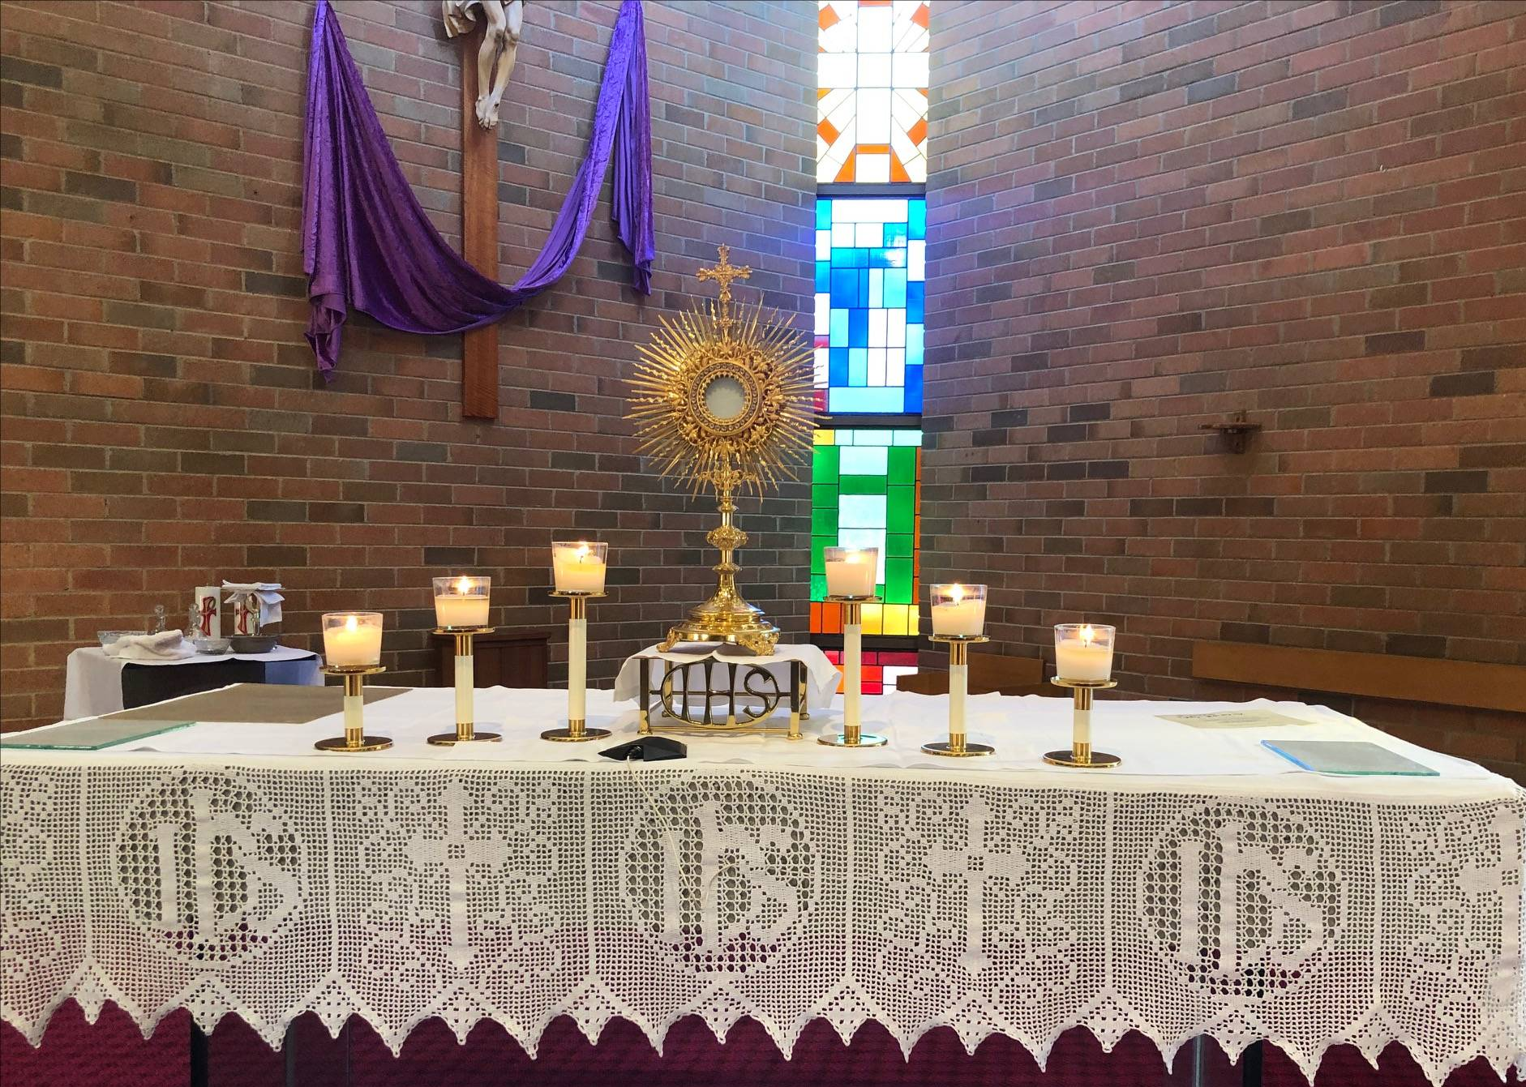
Pope Francis in Christ Lives Post-Synodal Apostolic Exhortation to Young People- speaks of the need to awaken and consolidate the great experiences of the Christian rather than giving mere doctrine that can bore young people, he quotes a powerful saying p.112 ”..’when we experience great love ... everything else become part of it’”. This is what The Book of heaven and writings of the Divine Will as dictated to Louisa by Jesus does.
Teaching by—emil.milat@cg.org.au

Volume 14
August 29, 1922
One who lives in the Divine Will receives the grafting of the works of Jesus and of the goods which they contain.

Continuing in my usual state, I was thinking about how much my sweet Jesus did and suffered to save souls; and He, on coming, told me: “My daughter, all that my Humanity did - prayers, words, works, steps and pains - is in act of giving itself to man. But who takes it? Who receives the grafting of my works? One who draws near Me and prays, uniting with Me, receives the grafting of my prayer and the goods it contains.
One who speaks, who teaches, united with Me, receives the grafting and the fruits of my words; and in the same way, one who works, who suffers, united with Me, receives the grafting and the goods which are contained in my pains and works.
Otherwise, all the goods which I acquired for the creature remain suspended; and not being grafted with Me, she cannot enjoy the use of the goods that my Humanity wants to give with so much love. If there is no union, the goods of one remain as though dead for the other.
Imagine a wheel: the center of the wheel is my Humanity; the spokes, all that It did and suffered; the circumference on which the spokes are fixed is the whole human family which rotates around the wheel. Now, if this circumference, this second circle of the wheel, does not draw near to receive the connection with the spokes, the spokes remain suspended and cannot communicate the goods which the center of the wheel contains.
Oh! how much I suffer in seeing so many goods of mine suspended, which human ingratitude not only does not receive, but despises and tramples. This is why with great eagerness I go in search for souls who want to live in my Will: to be able to fix in them the spokes of my wheel. My Will will give them grace, so as to be able to form the circumference of the second circle of the wheel, and they will receive all my goods which others reject and despise.”

“Nothing is insignificant or dull – everything can be sanctified, just as goats and sheep, fish and wheat, grapes and eyes of needles were given dignity as parables of the kingdom of God. Things the worldly wise would trample under foot become as precious to saints as pearls.”
Archbishop Fulton Sheen (Lift up Your Heart)
Volume 2

September 5, 1899
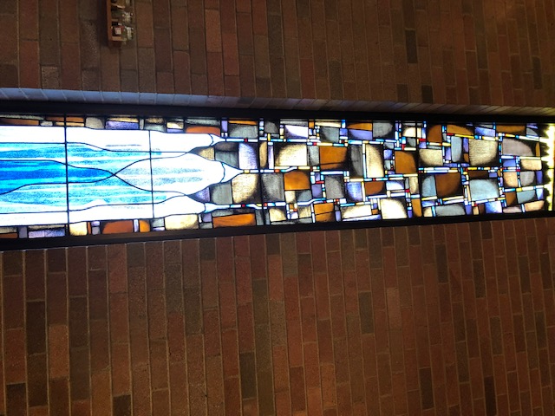
How Jesus operates perfection little by little.

This morning I found myself in such disheartenment and I saw myself so bad, that I myself rendered myself unbearable. When Jesus came, I told Him of my pains and the miserable state in which I was, and He said to me: “My daughter, do not want to lose heart. It is my usual way to operate perfection little by little, and not everything in one instant, so that, in seeing that she is always lacking something, the soul may push herself and make all efforts in order to reach what she lacks, to please Me more and to sanctify herself more.
And I, drawn by those acts, feel forced to give her new graces and celestial favors, and in this way a commerce, fully divine, forms between the soul and God.
Otherwise, if the soul possessed within herself the fullness of perfection and therefore of all virtues, she would not find the way to strive, and to please Me more, and so the tinder with which to start the fire between creature and Creator would be missing.”
May the Lord be always blessed!

