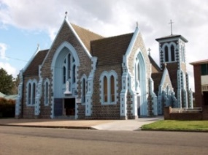
BAPTISM REQUEST FORM
Parish St Mary’s Parish, Crookwell
Baptism Details

Surname:
Christian names:
Date of birth: |  |  |  |  | Gender: |  | Male |  | Female
Place of birth:
Address:
Phone no: |  |  | Email:
Mother’s full name:
Phone no: |  |  | Email:
Mother’s maiden name:
Religion of mother:
Father’s full name:
Phone no: |  |  |  | Email:
Religion of father:
Place and date of parents’ marriage (church, denomination, etc.):
Names of Catholic Godparents:
Names of non-Catholic Christian witnesses & Religion:
Enrolment Evening- date:
Presentation (Mass to attend beforehand) -date:
Baptism is booked in for:
Date:
Church:
Time:

- Baptism Preparation will need to be undertaken.
- Unless provided - things to bring on baptism day – candle, white garment, offering envelope.

REQUEST FOR BAPTISM

We request the Sacrament of Baptism for our child
...........................................................................................................
We understand that Baptism is a Sacrament which gives the life of Christ to our child and that it makes our child a member of God's family, the Catholic Church.

And further:
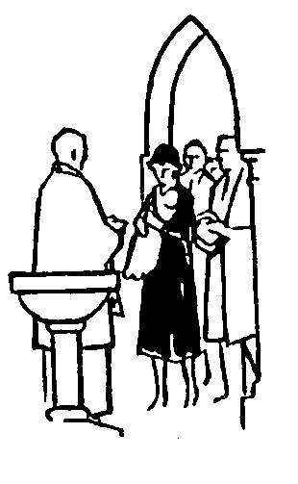
- We accept the responsibility of training our child in the practice of the faith and accept the duty of bringing our child up to keep God's Commandments as Christ taught us, by loving God and our neighbour.
- We understand the need to teach our child by the example of true Catholic living, to encourage family prayer and remain faithful to the attendance of Sunday Mass.
- We are aware of the need to prepare our child for the other Sacraments: Reconciliation, Communion and Confirmation.

We pray that God will keep us faithful to our obligations.

SIGNED..................................................AND....................................

NON CATHOLIC PARENTS (if necessary)
I find myself unable to profess my faith as explained above. I still wish my child to be baptised in the Catholic Church, and will assist my spouse as best I can in bringing our child up as a child of God.

SIGNED....................................................
_____________
DECLARATION BY GODPARENTS
We ….................................... and .......................................………….. have undertaken to act as Godparents for this child. We understand our obligations to pray regularly for, and set an example of Christian living, and help the child grow in faith and virtue.
SIGNED.................................and..............................……..
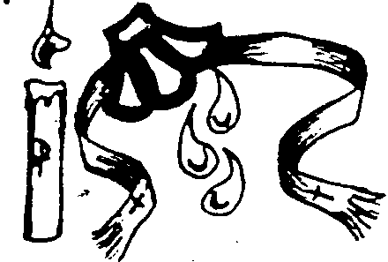
CHRISTIAN WITNESS. While sharing the same Baptism in the Father, Son and Holy Spirit I am not a Catholic. I will strive to assist the parents of this child in forming the child in joyful love and service of God and Man.
SIGNED........................................................................
THE CHILD MUST HAVE A CATHOLIC GODPARENT.

